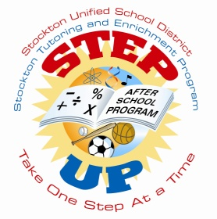
Step Up After School Program
Program Facilitator
February 9, 2022—12:30pm
Zoom



NOTES

AGENDA

Welcome

- Programming
  - I-ready (Math and English)-
  - additional academic enrichment: i.e., Reading with Relevance & Kidzlit
    - 5 days a week (either teacher or staff monitored)
  - Teacher led tutoring
    - When your students are at tutoring what does your staff do?
    - When your students return from tutoring, what does your program provide for your kiddos?
  - ASP Disneyland
    - Is your program providing out of box, fun, and engaging activities/project?

- End of the Day Attendance Reminder
  - Duplicates, Signatures, and ER codes

- Let’s Enroll more students
  - Adding large numbers of students with Dax support
  - Synergy

- Inventory

- Quality Standards
  - Surveys

- Upcoming trainings and workshops
  - Wellness & Self Care 2/16 or 2/17 (look for invite with specific date)
  - Legacy Summit 2/25/22
  - Workshops 12pm-1:30pm
    - ProCare support- tips and trick (3/1)
    - Sparks- what to look for (3/2)
    - up level your program (3/3)

- Next Meeting:
  - April (look for invite)

